Supplementary Material
for

A Cloud-Based Two-Layer Text Classification Framework for Mental Health Screening with Sarcasm and Emoji-Aware Sentiment Analysis

- Overview architecture diagram of the proposed framework

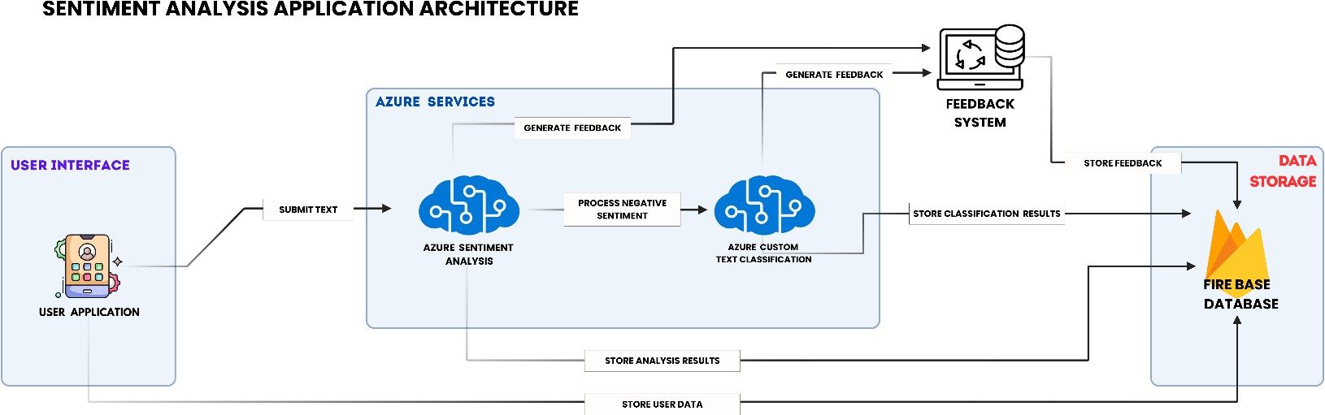
The image represents the overall architecture of the proposed framework, illustrating the complete workflow from user authentication and text submission through Azure-based sentiment analysis, mental health-related text classification, feedback generation, and secure data storage. The figure also highlights the interaction between the Android application, Azure cognitive services, and Firebase infrastructure that collectively enable real-time processing and monitoring.

- Sentiment Analysis and Mental Health-Related Text Classification Using Azure Services

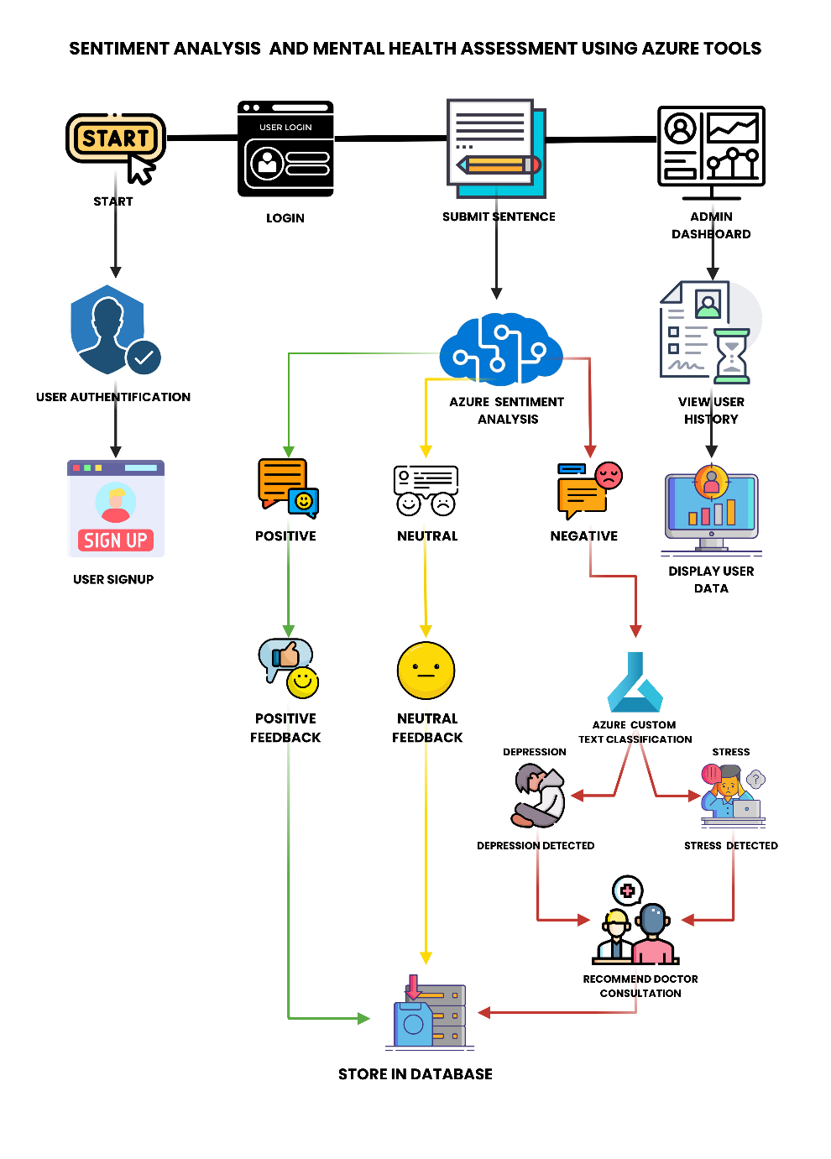
The image illustrates the complete workflow of the proposed framework, beginning with user authentication and ending with secure storage and administrative monitoring. The process starts when a user registers and logs into the Android application. Following authentication, the user submits free-form textual input, which is transmitted securely to Azure cloud services for analysis.

- Confusion matrix obtained using the clinically reviewed validation dataset (125 samples)

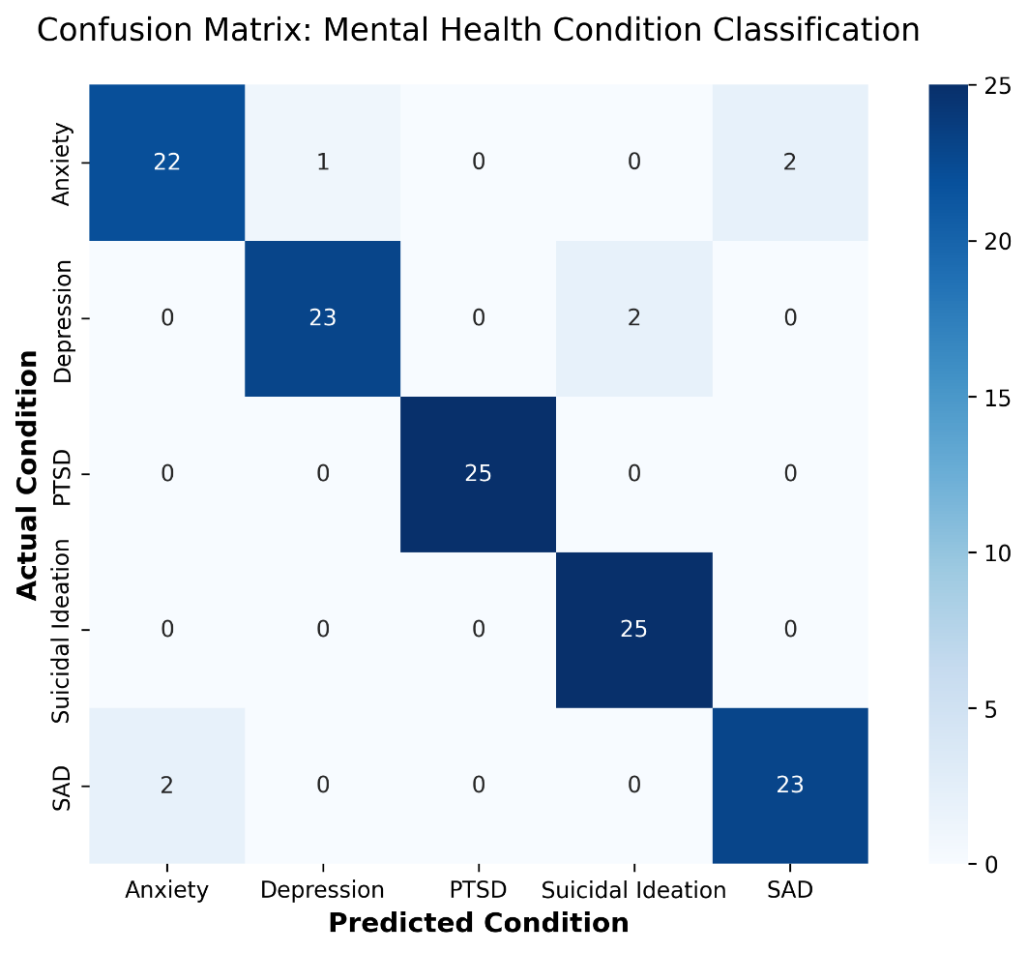

The matrix displays the distribution of actual versus predicted mental health conditions across 125 synthetic text samples (25 per category). The dark diagonal signifies high true-positive rates across all classes, with the model achieving perfect classification (25/25) for Post-Traumatic Stress Disorder (PTSD) and Suicidal Ideation. Off-diagonal values illustrate minor misclassifications occurring primarily between conceptually related conditions, such as the semantic overlap between Anxiety and Social Anxiety Disorder (SAD), as well as between Depression and Suicidal Ideation.

- Qualitative evaluation of sarcastic and informal language in mental health classification, and the influence of emojis on model confidence.
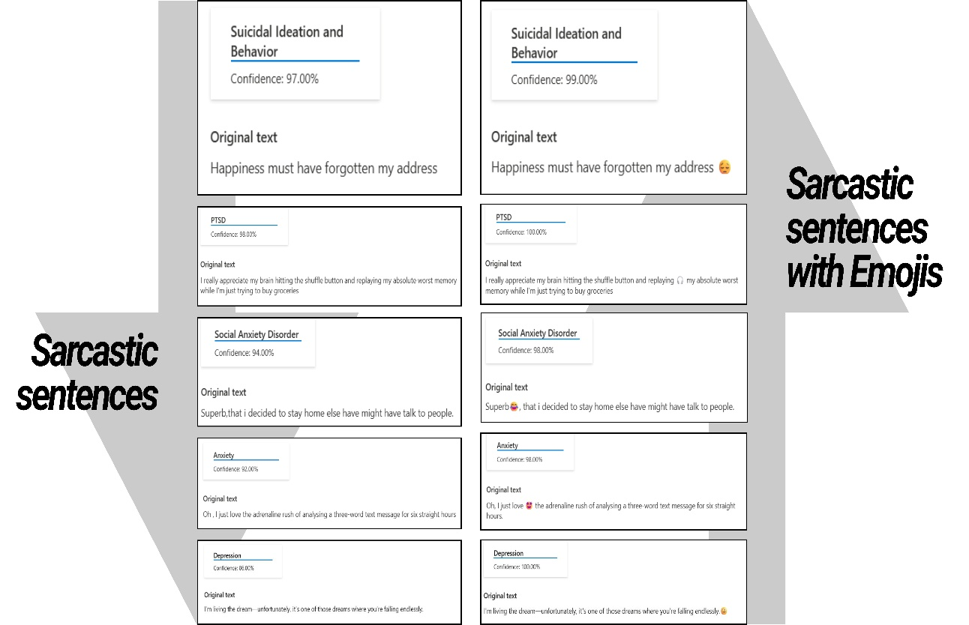

The left column shows original sarcastic sentences, while the right column shows the same sentences augmented with emojis. The framework successfully identified underlying mental health categories (Suicidal Ideation and Behaviour, PTSD, Social Anxiety Disorder, Anxiety, and Depression) despite surface-level sarcasm and indirect expressions. Adding contextually relevant emojis consistently increased classification confidence while preserving the predicted category.

(Images in zoomed version)

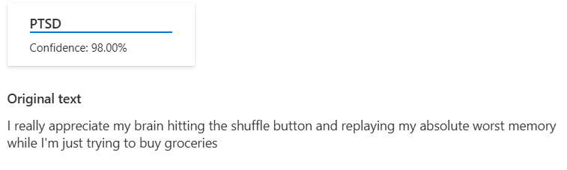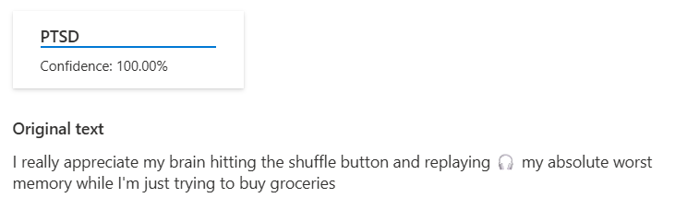
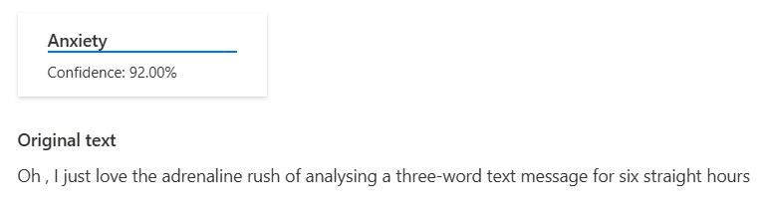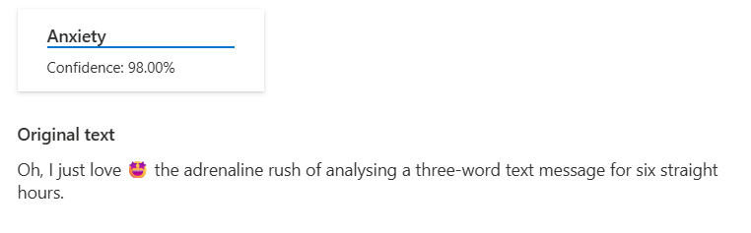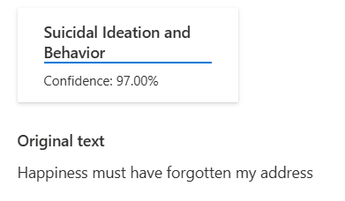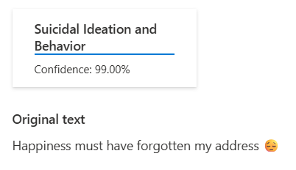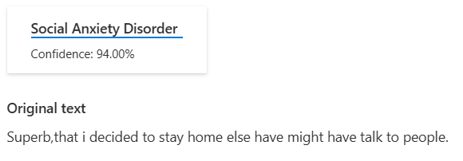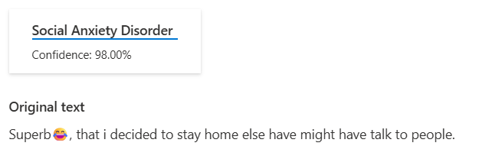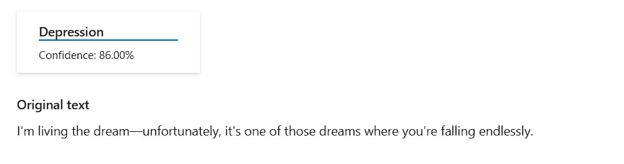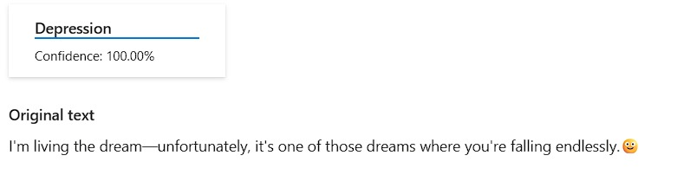

- Metrics Overview

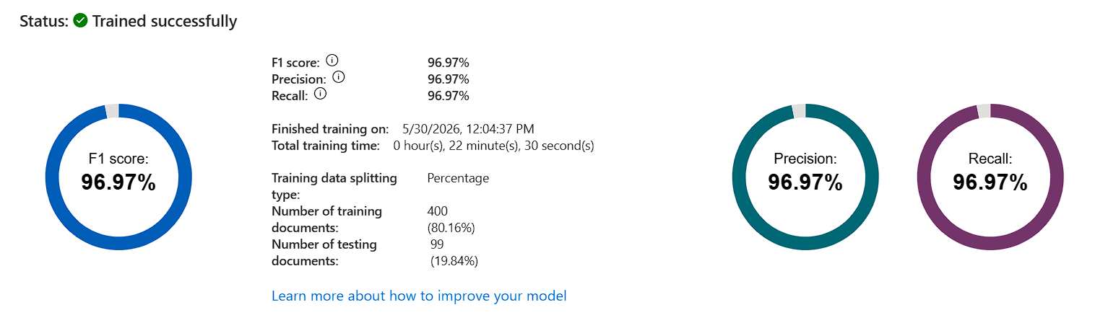

- Class Type Performance (Classification Performance on the Test Dataset)

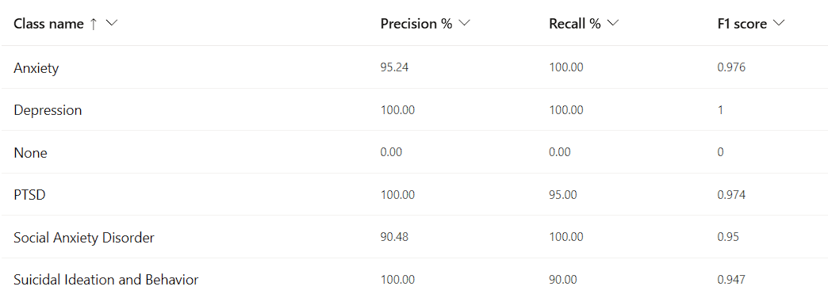

- Comparison with representative mental health classification studies reported
Model | Reported Metric
Bert [35] | Precision = 73.34 ; Recall = 81.38; F1 = 76.69
DistilBert [35] | Precision = 72.95 ; Recall = 78.67; F1 = 75.43
Persona-informed + Self-supervised[35] | Precision = 65.59 ; Recall = 82.29; F1 = 79.18
MultiResCNN [36] | F1=0.552
EffectiveCAN (Multi-layer attention) [36] | F1=0.581
EECAN (Multi-layer attention) [36] | F1= 0.585
Proposed Model | Precision = 96.97 % ; Recall = 96.97:  F1 Score = 96.97%

- Feedback Generation Algorithm

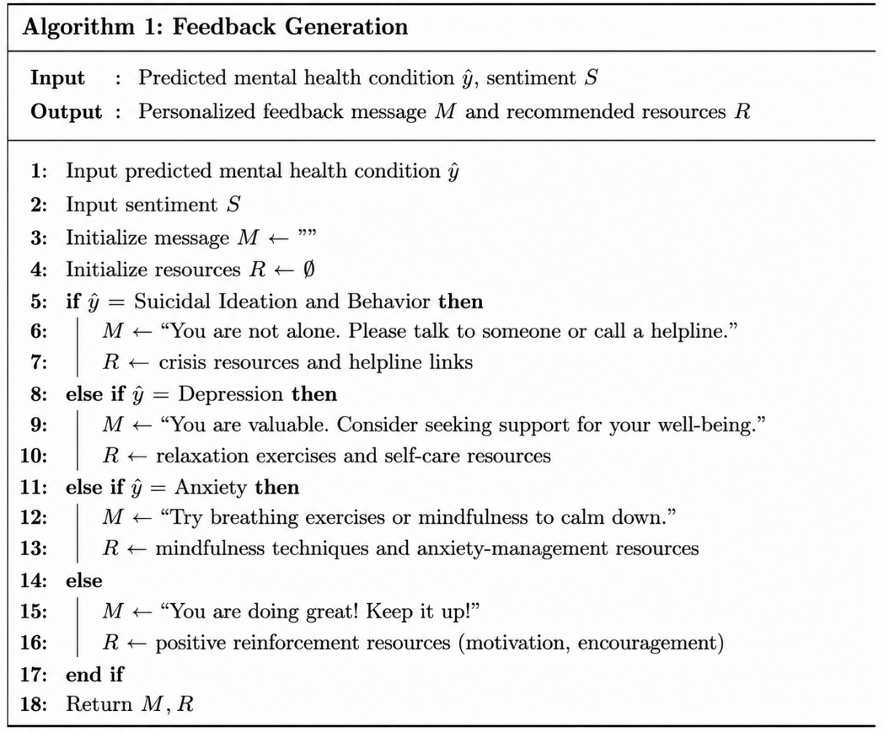

- Admin Monitoring and Reporting Algorithm

